Lab 7: Error Debugging with AI: Systematic approaches t0 finding and fixing bugs
Name: Dinesh
Rollno:2503a52374
Batch -13

Task Description -1: (Syntax Errors – Missing Parentheses in Print
Statement):
Task: Provide a Python snippet with a missing parenthesis in a print
statement (e.g., print &quot;Hello&quot;). Use AI to detect and fix the syntax
error

code with bugs :
# Bug: Missing parentheses in print statement

def greet():
print “Hello, AI Debugging Lab!”
greet()

prompt: Find the syntax error in this Python code. Explain why the error occurs and give me the corrected Python 3 code. Do not change anything else and give correct code
=>Fix the syntax error in my current Python file. Keep the function name greet() and add at least 3 assert test cases to verify that the corrected program works.

correct code :

def greet():
print("Hello, AI Debugging Lab!")

def _run_tests():
assert greet.__name__ == "greet"
assert callable(greet)
assert greet() is None

# Verify the corrected program works.
greet()
_run_tests()
Output:
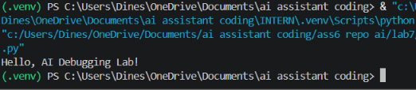
Justification:
This task helped us understand how syntax errors occur and how AI tools can quickly identify and explain simple coding mistakes.

Task Description -2 (Incorrect condition in an If Statement)
Task: Supply a function where an if-condition mistakenly uses =
instead of ==. Let AI identify and fix the issue.

# Bug: Using assignment (=) instead of comparison (==)
def check_number(n):
if n = 10:
return “Ten”;
else:
return “Not Ten”;
prompt:
Find the error in my current Python code. Explain why using = inside an if condition causes an error, and explain the difference between = and ==. Then provide the corrected code.
=>Fix the error in my current Python file by replacing = with ==. Add at least 3 assert test cases to verify the function works correctly for 10, a number other than 10, and another different number. Keep the code simple for a beginner.
Correct code:
def check_number(n):
if n == 10:
return "Ten"
else:
return "Not Ten"

# Test the function
print(check_number(10))
print(check_number(5))

# Assert Test Cases
assert check_number(10) == "Ten"
assert check_number(5) == "Not Ten"
assert check_number(20) == "Not Ten"

print("All 3 assert test cases passed!")

Output:
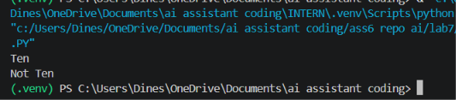
Justification:
This task helped us understand that a program can run without errors but still produce wrong results. AI-assisted analysis can help identify such logical mistakes.

Task Description -3 (Runtime Error – File Not Found):
Task: Provide code that attempts to open a non-existent file and
crashes. Use AI to apply safe error handling.

# Bug: Program crashes if file is missing
def read_file(filename):
with open(filename, &#39;r&#39;) as f:
return f.read()
print(read_file(“nonexistent.txt”;))
prompt:
Fix this code using try-except. Handle missing and invalid files with a simple error message. Keep the read_file() function and test 3 cases: existing file, missing file, and invalid path.
Correct code:
def read_file(filename):
try:
with open(filename, 'r') as f:
return f.read()
except (FileNotFoundError, OSError):
return "Error: file not found or invalid path."

# Test 1: existing file
import tempfile

with tempfile.NamedTemporaryFile("w+", delete=False) as temp:
temp.write("hello from temp file")
existing_file = temp.name

assert read_file(existing_file) == "hello from temp file"

# Test 2: missing file
missing_file = "nonexistent.txt"
assert read_file(missing_file) == "Error: file not found or invalid path."

# Test 3: invalid path
invalid_path = ""
assert read_file(invalid_path) == "Error: file not found or invalid path."

print(read_file(existing_file))
print(read_file(missing_file))
print(read_file(invalid_path))

output:
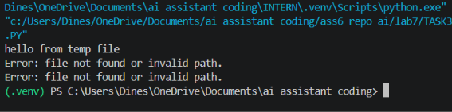
Justification:
This task demonstrated the importance of exception handling. Instead of allowing the program to crash, errors can be handled safely and user-friendly messages can be displayed.

Task Description #4 (Calling a Non-Existent Method)
Task: Give a class where a non-existent method is called (e.g.,
obj.undefined_method()). Use AI to debug and fix.
# Bug: Calling an undefined method
class Car:
def start(self):
return “Car started”;
my_car = Car()
print(my_car.drive()) # drive() is not defined

prompt:
Fix this error and explain whether I should add drive() or change the method call. Add 3 assert tests.
Correct code:
# Lab 7 - Task 4
# Calling a Non-Existent Method

class Car:
def start(self):
return "Car started"

my_car = Car()

print(my_car.start())

# Assert test cases
assert my_car.start() == "Car started"
assert isinstance(my_car.start(), str)
assert len(my_car.start()) > 0

print("All 3 assert test cases passed!")

output:
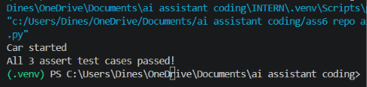
Justification:
This task helped us understand how object-oriented programming errors can occur when calling undefined methods and how AI can help determine an appropriate correction.

Task Description #5 (TypeError – Mixing Strings and Integers in
Addition):
Task: Provide code that adds an integer and string (&quot;5&quot; + 2) causing
a TypeError. Use AI to resolve the bug.

# Bug: TypeError due to mixing string and integer

def add_five(value):
return value + 5
print(add_five(“10”))
prompt:
Fix this TypeError and give me 2 solutions: one using type casting and one using string concatenation. Also add 3 assert tests.
Correct code:
# Lab 7 - Task 5
# TypeError: Mixing String and Integer

# Solution 1: Type Casting
def add_five(value):
return int(value) + 5

print("Type Casting Solution:")
print(add_five("10"))
print(add_five("20"))
print(add_five("0"))

# Assert Test Cases
assert add_five("10") == 15
assert add_five("20") == 25
assert add_five("0") == 5
print("All 3 assert test cases passed!")

# Solution 2: String Concatenation
def add_five_string(value):
return value + str(5)
print("\nString Concatenation Solution:")
print(add_five_string("10"))
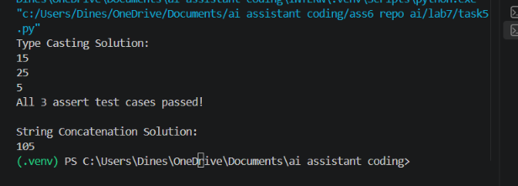
Justification:
This task helped us understand Python data types and type conversion. It also demonstrated that the correct solution depends on whether we want numerical calculation or text concatenation.

